


From information to insight—instantly

MASS

Maritime Autonomous Surface Ships

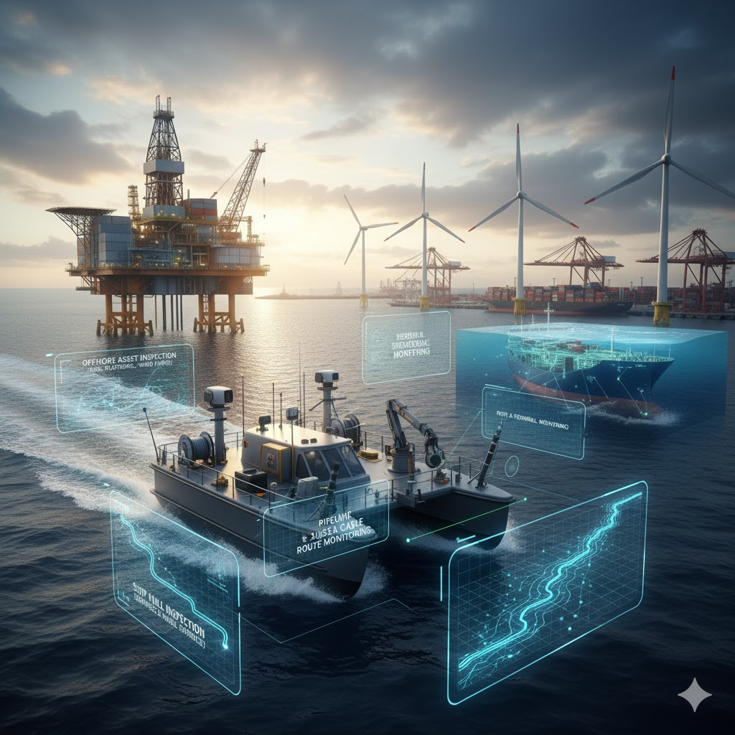

This white paper was researched and authored by Chanda Wagh, Technical Writer & Quality Coordinator with hands-on experience documenting AI-based Maritime Autonomous Surface Vessel (MASS) systems, collision avoidance platforms, and defense-grade compliance documentation.

Table of Contents

1 Executive Summary 3
2 Integrated Sensor Architecture 3
3 AI-Driven Autonomous Navigation 4
4 Ground Station Command & Control 4
5 Future Development Roadmap 5
6 Market Drivers & Growth Projections 5
7 Market Drivers & Growth Projections 6
8 Case Study 6
9 Conclusion 6
10 References 7

Executive Summary

Mission-Critical Capabilities
A modular, hardware-agnostic software suite delivering adaptive maritime surveillance and AI-driven collision avoidance for MASS vessels. Designed for seamless integration with both legacy and next-generation platforms, it combines advanced perception, autonomous navigation, and real-time connectivity to ensure reliable performance in complex and contested maritime environments. Its scalable architecture supports seamless capability upgrades as mission demands evolve, ensuring long-term operational viability
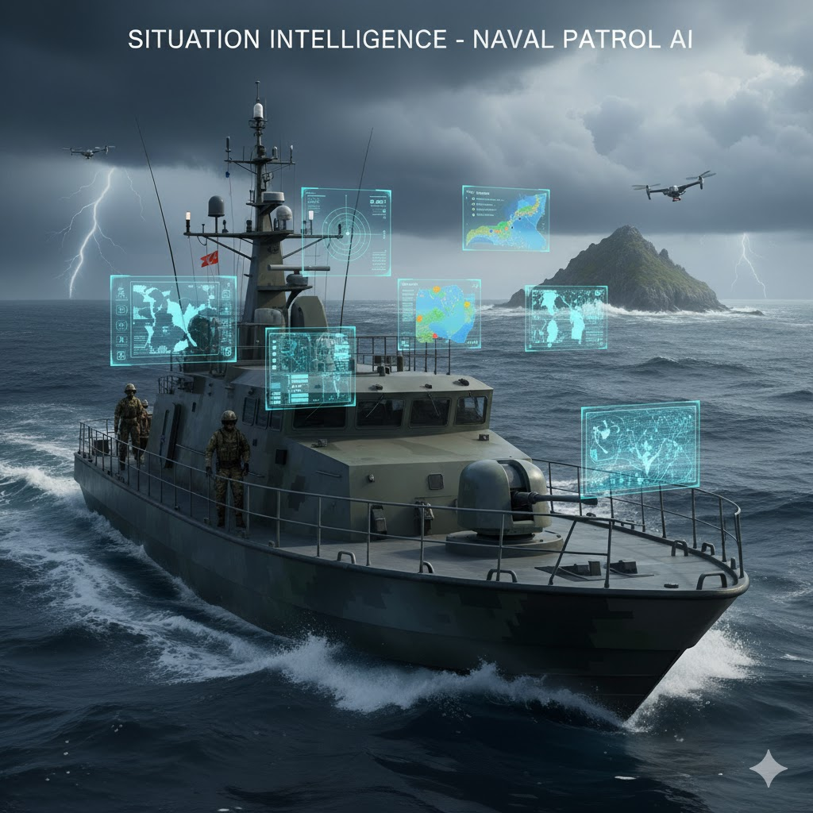

Strategic Advantage

The MASS removes personnel risk while enabling persistent maritime surveillance and mission support across defense, commercial, environmental, and emergency-response domains. It can deliver actionable intelligence through fully autonomous operations in demanding sea states, using adaptive path-planning algorithms that respond to evolving threats, operational demands, and dynamic environmental conditions

Integrated Sensor Architecture



Maritime Radar Systems


Navigation Sensors
X-band and S-band radar arrays can deliver full 360° situational coverage for vessel detection, collision avoidance, and navigation support, continuously tracking targets and providing automated threat classification for enhanced maritime awareness.
Military-grade IMU and INS providing positional accuracy within 1 metre. RTK-GPS with GNSS redundancy ensures continuous navigation even in GPS-denied environments through sensor fusion algorithms.




Environmental Monitoring

Electro-Optical Suite

The software can ingest and process multi-spectral data from dual thermal and visual camera systems on gyro-stabilized gimbals, ensuring high-fidelity imaging in all lighting and weather. It can interpret long-wave infrared streams for heat-signature detection and analyze RGB feeds to support precise target identification, classification, and verification.
Integrated depth sounders, anemometers, and temperature sensors continuously assess operating conditions. Their real-time environmental data can flow directly into the software’s autonomous decision-making algorithms, enabling optimized route planning and safer navigation.

3




Situational Awareness
Machine learning models fuse radar tracks, AIS data, and visual detections to classify contacts, predict intentions, and assess collision risk in real-time.

Dynamic Path Planning
AI algorithms compute collision-free trajectories compliant with International Regulations for Preventing Collisions at Sea (COLREGs), adapting to traffic density and mission priorities.

Threat Response
Autonomous decision-making enables rapid response to hostile contacts, environmental hazards, or system failures, executing pre-programmed tactical behaviors without operator intervention.

AI-Driven Autonomous Navigation

Ground Station Command & Control

Remote Intervention
3
1

Real-Time Monitoring
The software supports high-bandwidth satellite communication, enabling continuous streaming of sensor data, vessel telemetry, and environmental parameters to shore-based operators with minimal end-to-end latency.
Operators can take direct control or adjust mission parameters at any time through the command interface. Built-in emergency-stop protocols allow instant intervention in response to unexpected conditions.

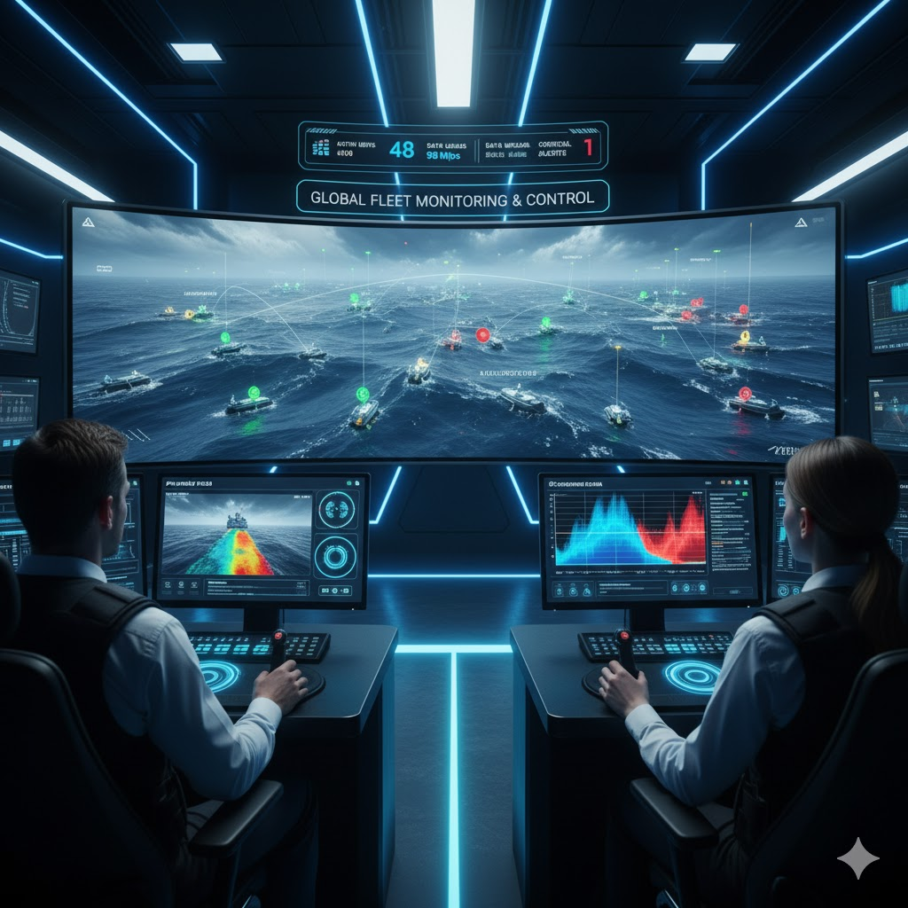

Mission Planning
2

The intuitive interface enables rapid mission planning with automated route generation, power-use estimates, and risk assessments, providing operators with clear validation before execution.

4

Future Development Roadmap

2028: Global Deployment
3

2026: Enhanced Autonomy
1

Future USV systems will implement swarm intelligence to enable coordinated, multi-vessel operations. Advanced AI algorithms will incorporate predictive threat assessment and collaborative mission planning, allowing MASS fleets to operate autonomously and synergistically across complex maritime environments
Future MASS platforms are expected to include Arctic-hardened variants capable of extended polar and extreme-weather operations. Evolving modular mission bays will support even faster reconfiguration, enabling next-generation roles in autonomous hydrographic surveying, long-endurance maritime patrol, precision interdiction, and integrated multi-domain mission support

2027: Expanded Capabilities
2

2029: AI Maturation
4

Integration of underwater drone deployment systems for subsurface surveying. Advanced electronic warfare suites providing signals intelligence gathering and communication jamming capabilities.
Fully autonomous decision-making for complex tactical scenarios. Reduced ground station dependency enabling operations in communications-denied environments with pre-programmed response protocols.

Market Drivers & Growth Projections

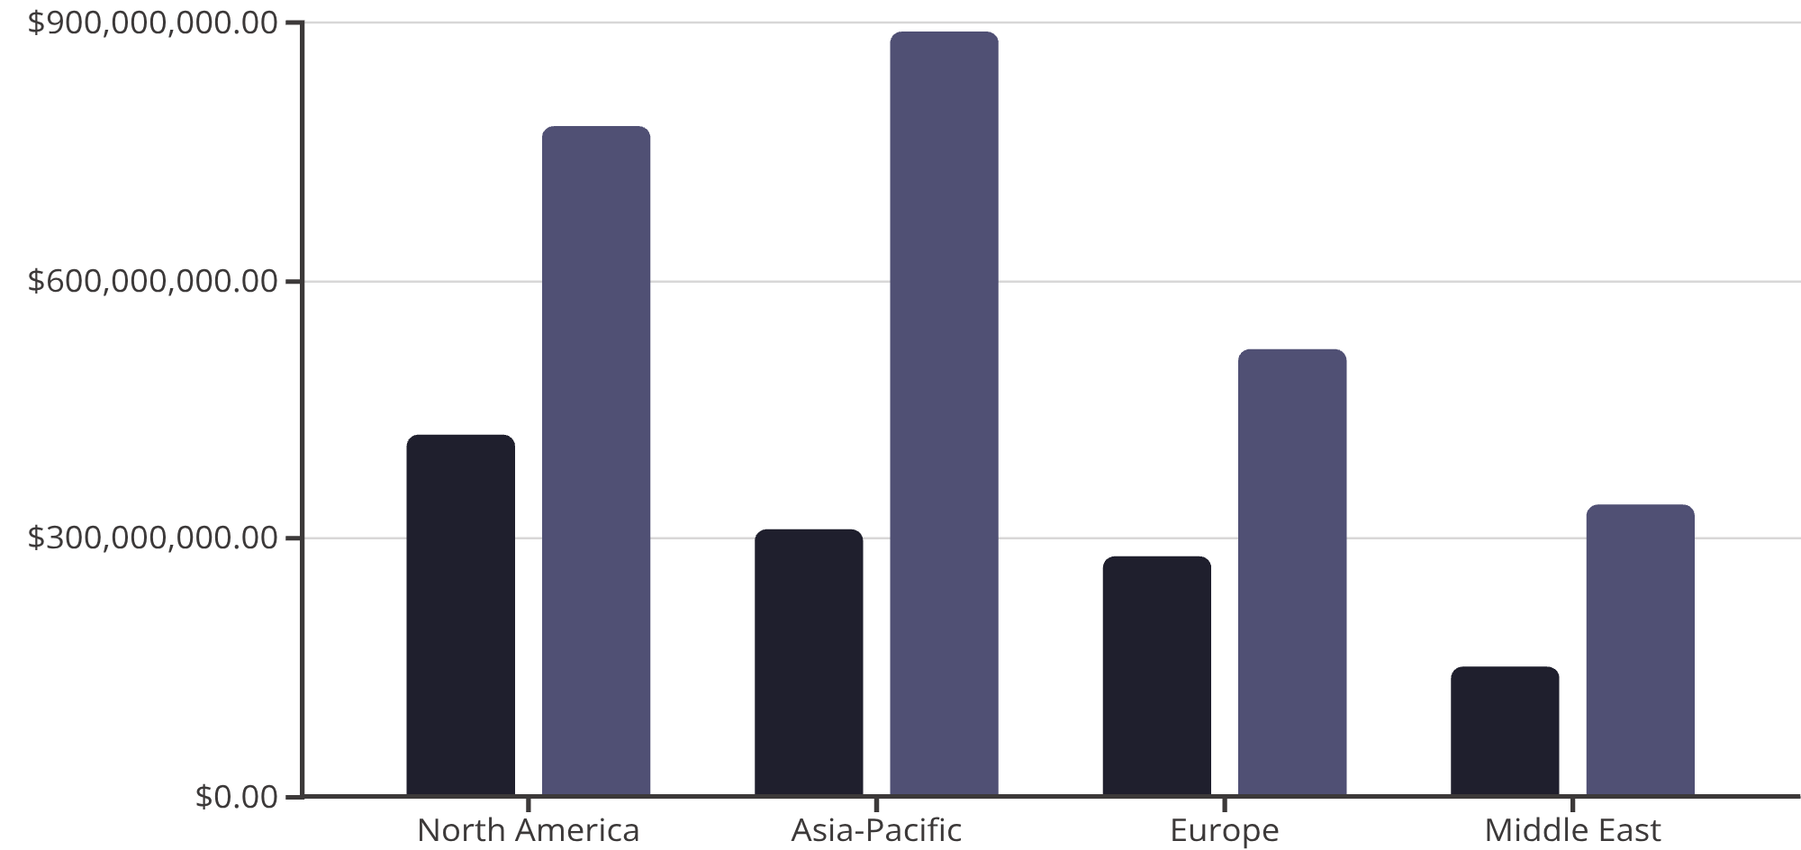

The global military MASS market demonstrates robust expansion, driven by strategic imperatives to enhance maritime domain awareness whilst reducing personnel exposure to hostile environments.

2024
2030 Projection

5
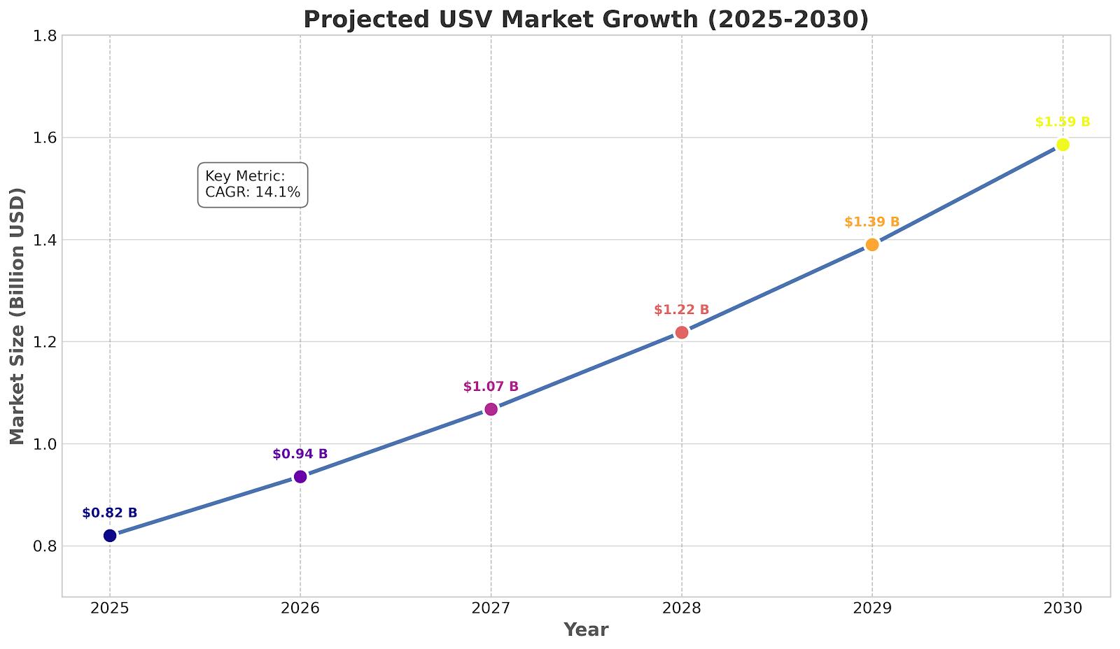

Market Drivers & Growth Projections

Case Study

- TideWise (Brazil): Deployed EIVA's NaviSuite Kuda for hydrographic surveys, achieving high-quality data collection and operational flexibility with modular software.
- Sonardyne Navigation: Utilized advanced navigation and sensor fusion in long-duration survey missions under challenging sea conditions, demonstrating high reliability and data accuracy.
- SEA-KIT: Employed Cambridge Pixel’s radar and situational awareness software to enhance remote operations and obstacle detection during offshore surveys.
- AI Collision Avoidance: Implemented real-time, AI-driven algorithms that optimize autonomous maneuvering and collision avoidance, significantly improving safety in complex, dynamic environments

Conclusion

MASS vessel are rapidly becoming essential assets for modern maritime missions, delivering persistent coverage, reduced human risk, and high-precision autonomy. Advances in sensors, AI navigation, and modular architectures now enable reliable operation in complex and contested environments. As capabilities evolve toward swarm coordination and predictive decision-making, MASS will further expand mission effectiveness across defense, commercial, and environmental domains. Their growing role signals a clear shift towards smarter, safer, and more efficient maritime operations.

6
7
DOCUVELLUM
From information to insight — instantly

Author: Chanda Wagh
Technical Writer & Quality Coordinator
Defence | AI/Robotics | Aerospace Documentation
📧 chandrawagh22@gmail.com
📞 +91 7798079098
🔗 github.com/chandacreate/docuvellum-portfolio
© 2026 Chanda Wagh | All Rights Reserved

References
- Grand View Research (2024). Unmanned Surface Vehicle Market Size & Forecast 2025–2030. grandviewresearch.com
- Markets and Markets (2024). Military USV Market — Global Forecast to 2030. marketsandmarkets.com
- International Maritime Organization (IMO). COLREGS — Convention on the International Regulations for Preventing Collisions at Sea. imo.org
- Sonardyne International (2024). Autonomous Navigation & Sensor Fusion for USVs. sonardyne.com
- SEA-KIT International (2024). Uncrewed Surface Vessels for Offshore Survey. sea-kit.com

